Chapter 2, Problem 81.

In a certain application, the circuit in Figure 2.140 must be designed to meet these two criteria:
(a) V_{o} / V_{s} = 0.05 (b) R_{eq} = 40 kΩ

If the load resistor 5 kΩ is fixed, find R₁ and R₂ to meet the criteria.
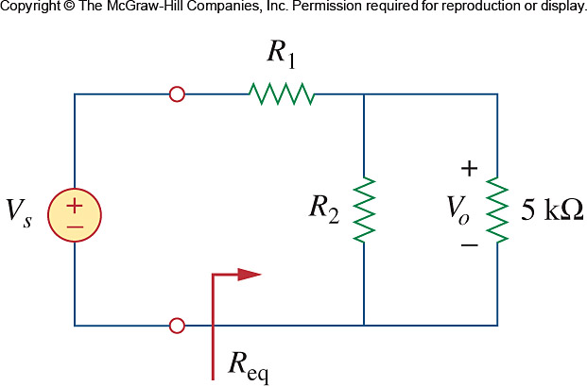

Figure 2.140
For Prob. 2.81.

